**RC & Pod label selector**

Assume there is an RC created with labels. The labels given to Pod in the Pod template metadata are used by RC selector to identify the Pods and take control on them.

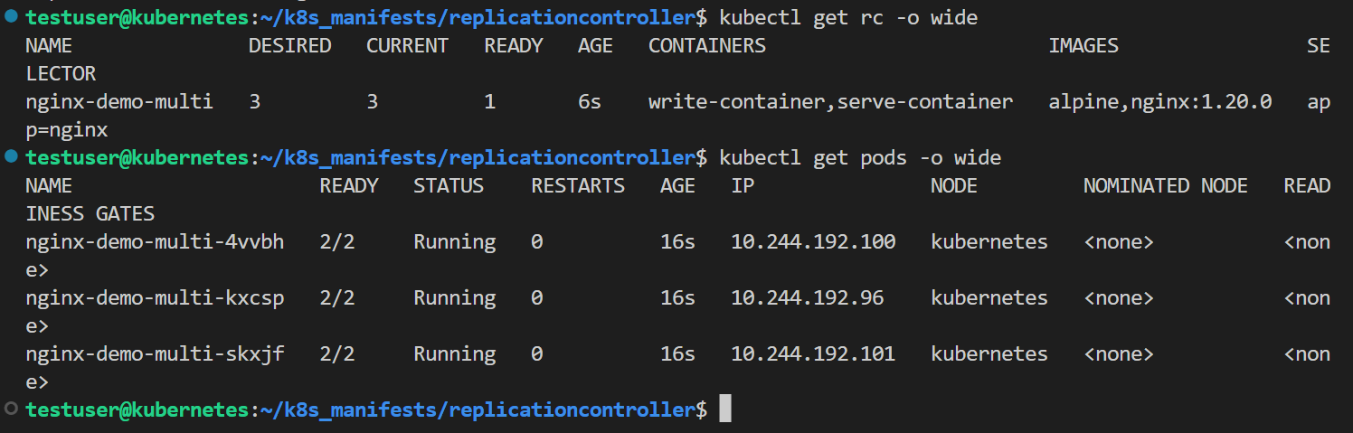

To see all the labels of the pods, use the command – **kubectl get pods -o wide** --**show-labels.**

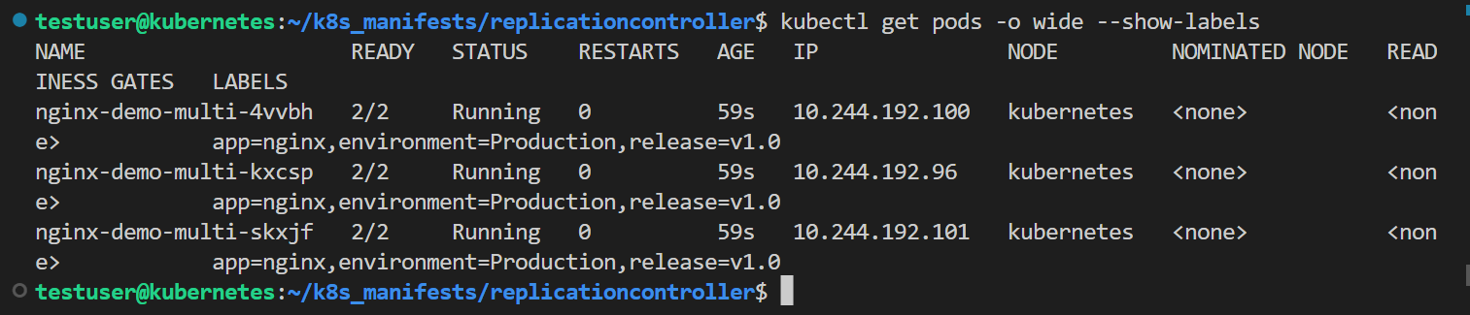

If any label of the Pod which is same as RC selector is removed, then the RC loses it control on the Pod. To remove the label of a pod, use the command –   
**kubectl label pods <pod_name> <key of the label>**- . To remove a label of the pod only the key of the label followed by a “-” is given no need to write the value of the key.



Now check the labels of the Pod, use the command - **kubectl get pods -o wide** --**show-labels.** Immediately RC starts creating a new pod because one of the Pods is mismatching with the labels. Now, the Pod to which the labels are removed isn’t controlled by RC but still remains in running state as a standalone Pod. As desired state is 2, RC starts creating a new Pod to match it.

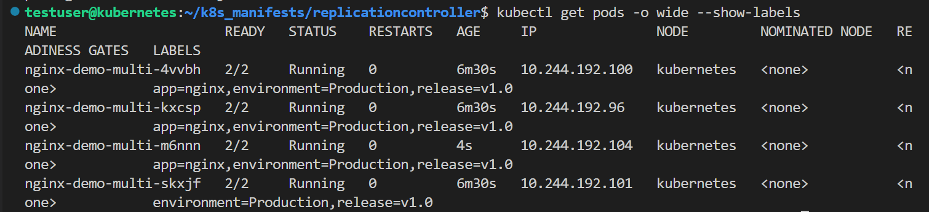

To re-add the label to the pod, use the command – **kubectl label pods <pod_name> <key:value>**



Now check if the label is added to the Pod or not, use the command -   
**kubectl get pods -o wide** --**show-labels.** Immediately, the additional Pod gets deleted to match the desired state of RC.

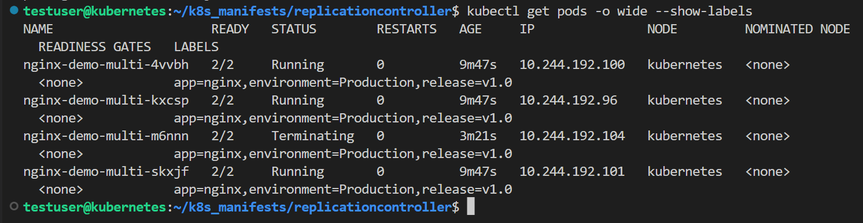

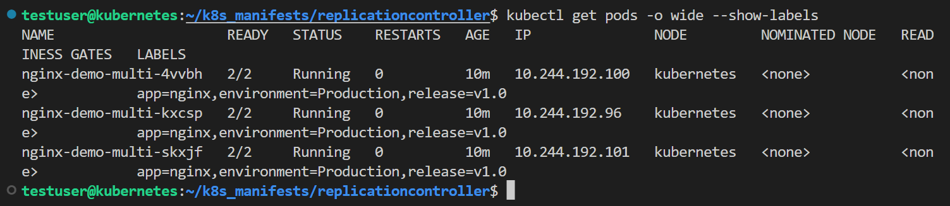

**Note: If an maintenance work or Patch work is to be done on containers in a specific Pod, then to bring out that specific Pod from RC, removing labels concept can be used. Once all maintenance and patch work is done on the container, the Pod can be added back to the control of RC by adding label to the Pod.**

If selector section isn’t added in the spec of the RC, then automatically all the labels in the Pod template get added to the RC.

Delete all the available RCs and recreate the RC without selector section in spec, use the command - **Kubectl create -f nginx-multicontainer.yaml**

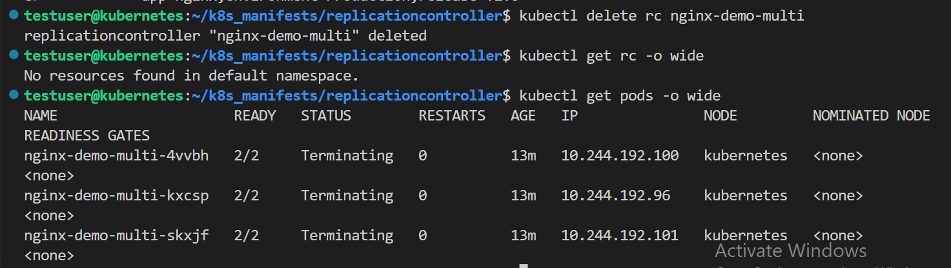

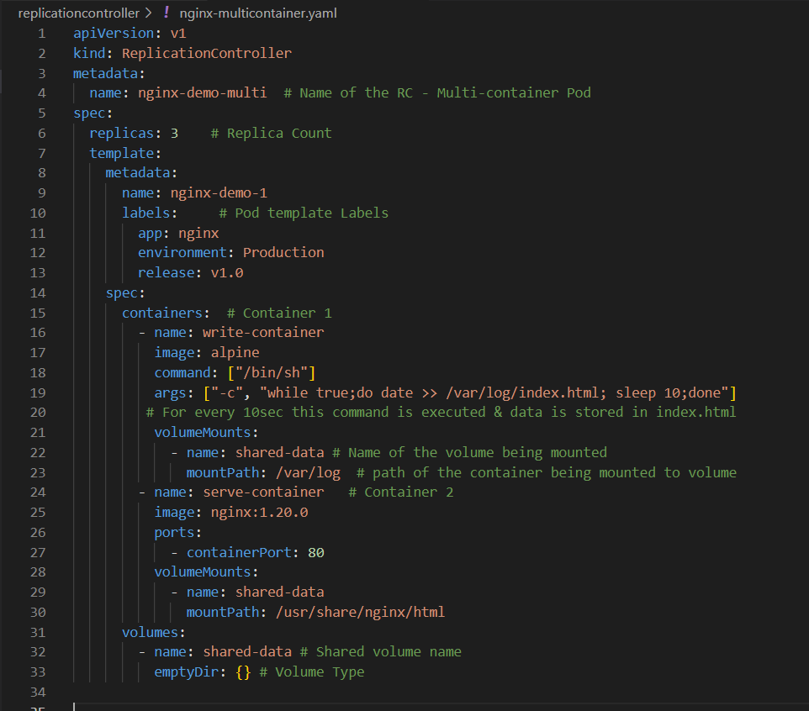



Now check the status of the RC, to see what labels are selector labels are added to it, use the command - **kubectl get rc -o wide**

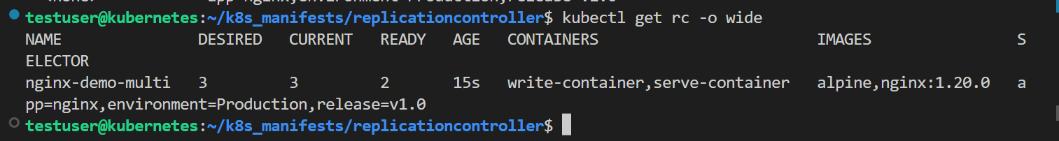

Also check the Pods running status, use the command - **kubectl get pods -o wide**

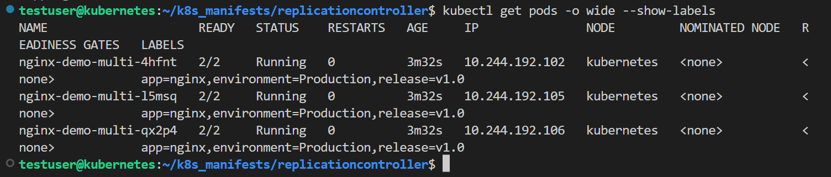

For the clean up delete the RC not the pods and check the status of both Pods and the RC

